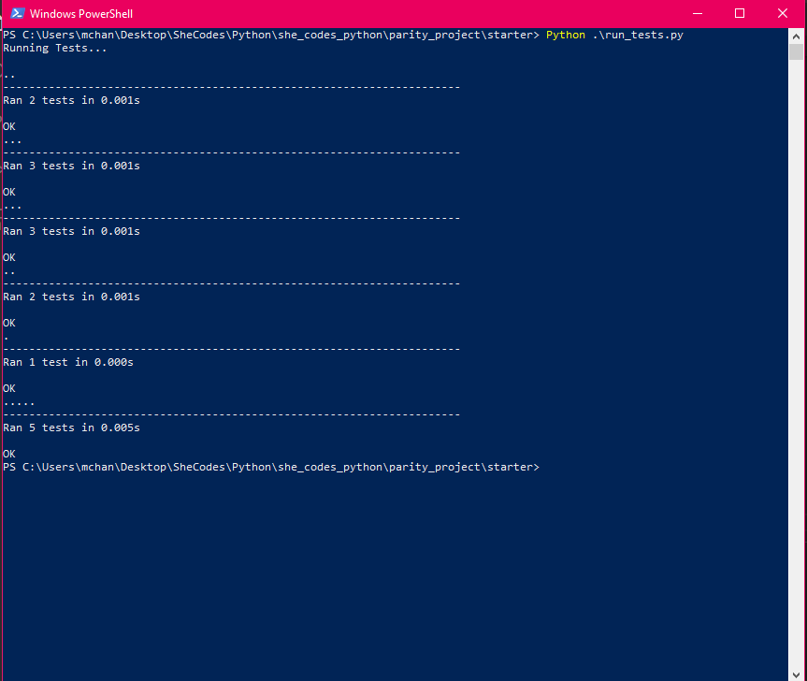

<https://github.com/aeineeuq/SheCodes-Projects/tree/main/Python/parity_project>